

development of an art analyser AUTOMATED machine

Step by Step Guide

june 2017

Sergi martínez, marc molet, josep pomés, albert rovira

Universitat de Vic

# Step by Step Guide**:**

This is an automated machine able to move in the three Cartesian axis. You can control it with any PC via single movements or by programming a sequence.

Because it is oriented to analyse and map art samples, it has an easy-changing tool where different cameras and sensors are attached. We can also control some parameters such as the illumination.

## 1. Specifications

Before starting with the project, we would like to remark all the specifications of the Machine you will get after finishing this step by step guide.

Axis details:

* X-axis
  + **Travel:** 240 mm
  + **Drive:** Toothed Belt
  + **Speed:** 30 mm/s (nominal)
  + **Acceleration:** 900 mm/s2
  + **Resolution:** 0.1 mm
* Y-axis
  + **Travel:** 260 mm
  + **Drive:** Toothed Belt
  + **Speed:** 30 mm/s (nominal)
  + **Acceleration:** 900 mm/s2
  + **Resolution:** 0.1 mm
* Z-axis
  + **Travel:** 180mm
  + **Drive:** Leadscrew
  + **Speed:** 10mm/s (nominal)
  + **Acceleration:** 900 mm/s2
  + **Resolution:** 0.1 mm

Other characteristics:

* Free and open source firmware and software.
* Fixed base (the motion of the Z-axis is not implemented in the base).
* Cheap and reused materials.
* Conventional manufacturing processes and 3D printing.
* The cost of the project will be lower than 250€.

## 2. Design and patterns

Our first concept of the prototype was that it had to be light and easy to replicate. Therefore, when we started translating our ideas into the computer we made the pieces thinking with the 3D impression.

The first stage of the drawing was to recreate with the Rexroth profiles all the edges of the cube.

Next, we began drawing the whole system for the horizontal movements X and Y, which we transform from the circular motion of the motors, to a linear movement through transmission belts.

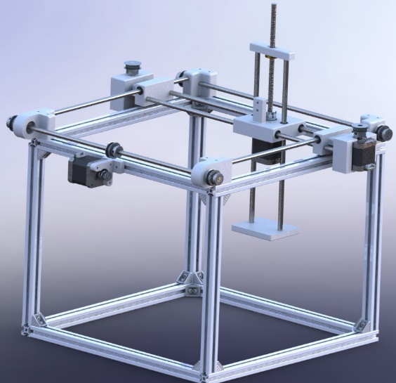

Definitive structural design.

Once we had the idea of the horizontal movements, we started to implement the motor and the movement system of the Z axis (vertical). With the coupling of the worm screw fixed to the axis of the motor and through the nut of the screw worm, we converted the motor movement to a slow and precise vertical movement.

Up to this point, the structural design phase was implemented with all the possible movements and we simulated them with the computer to identify potential problems.

Once the three movements were tested it was the turn to design the head where the controller, cameras and led would go. We designed it to be completely modular and easy to implement different LED, cameras or sensors.

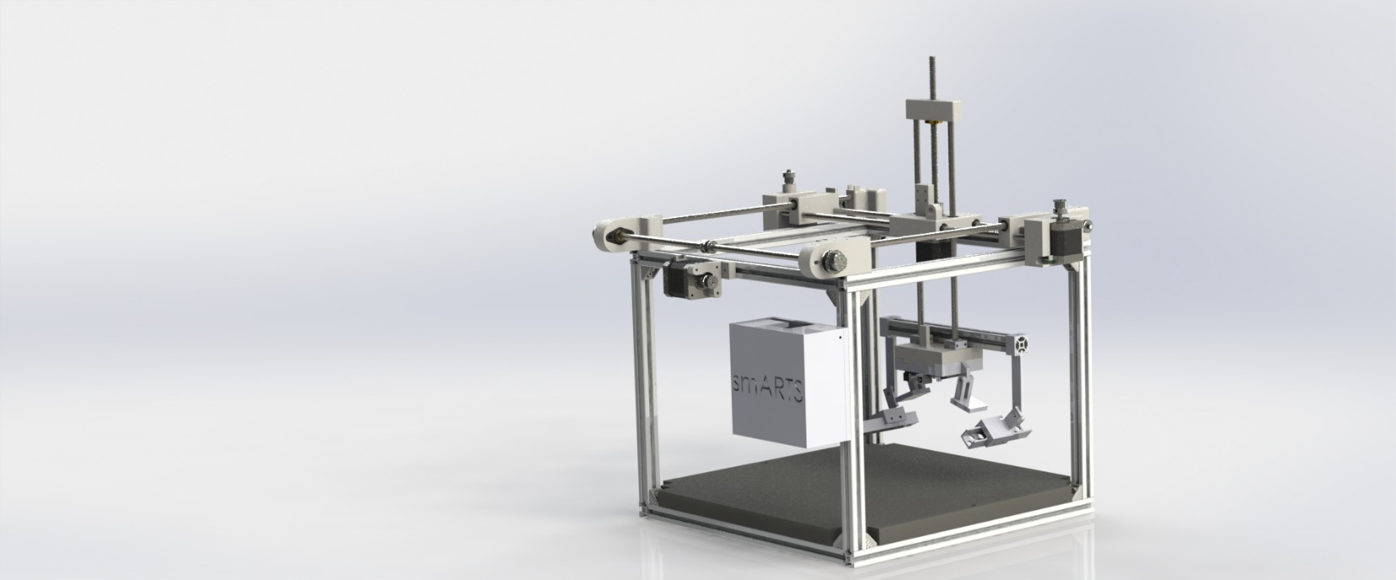

Complete design.

Finally, as we designed the pieces, we already thought about the time when we would create the step by step guide. We came up with the idea to facilitate the explanation and at the same time the assembly so we engrave the pieces with numbers to facilitate it.

## 3. Required Tools

To make the work more agile and not wasting so much time searching the necessary tools for a satisfactory assembly, we will provide a list of the necessary tools to facilitate the assembly. Besides in some tools we will propose alternative ones if the tool is not available.

### Tool list:

|  |  |
| --- | --- |
| 3D Printer  It is the fundamental mainstay of the project. We need it to 3D-print all the parts before starting with the final assembling. | 3D PRINTER BCN3D Sigma |
| Tape measure  You might have heard the saying "measure twice, cut once". Well, you need a tape measure for measuring all the parts you will have to cut. | tape measure |
| CNC milling machine / Hacksaw  On our case, we cut the rods and axes for the linear movement with a CNC milling machine for greater accuracy, but if in your workplace you do not have this machine, you can use a hacksaw. Be sure to have the exact measurements. | CNC millingHacksaw |
| Screw drivers and Allen wrenches:  These two sets are necessary to unscrew and screw all those screws used in the union of parts and fixings. | C:\Users\usuari\AppData\Local\Microsoft\Windows\INetCache\Content.Word\Allen wrenches.jpg |
| Files:  Used to polish 3D printing imperfection and file the saw-cutted corners. | files |

|  |  |
| --- | --- |
| Pliers:  Different types of pliers are needed to hold the female for a more comfortable attachment of the screw. | Pliers |
| Scissors:  Useful to cleanly cut the excess belts once assembled and peel the wires. | Scissors |
| Glue gun:  It is not a necessary tool, but it can be useful for orderly fixing some annoying wire. | glue gun |
| PPE (Personal Protection Equipment):  Do not forget in every mechanical assembly where cutting tools and sharp tools are used. Use the appropriate PPE in each situation. | PPE |

## 4.Required materials

In this part, we will comment some materials used and the quantity we will need of each one. We will not enter in some details as the exact price and where to buy them. Trust us, they are very easy to find and we guarantee you that the cost will not exceed 250€ (if you look for them carefully you probably find all the material for around 200€).

If you want to know how to assemble the materials, please go to the following step.

To make the project reality, we will need to prepare these materials (check the document *“Material List”* to know the specifications of these materials):

|  |  |
| --- | --- |
| * Rexroth (6m) | * Stepper motors (3 units) |
| * Rexroth Corners + Fixation Game (24 units) | * PLA Coil (1Kg) |
| * M3 and M4 Screws | * Lead Screw + nut (1 units) |
| * Engine Coupler Lead Screw (1 units) | * Linear bearings (10) |
| * Stainless steel rod (6m) | * Arduino Mega (1 units) |
| * Synchronous Pulleys - GT2 5mm (3 units) | * Belt-GT2 (4m) |
| * Transmission Pulleys A - GT2 8mm (3 units) | * Endstop (3 units) |
| * Transmission Pulleys B - GT2 5mm (2 units) | * Power supply (1 units) |
| * Stepper motor drivers-DRV8825 (3 units) | * Igus bearing (2 units) |

Once we have the materials, we have to cut the Rexroth, the stainless steel rod and the lead screw, in specific measures to be able to proceed to the assembly, the rest of materials does not need be changed.

|  |  |
| --- | --- |
| Rexroth measures:   * 4 bars of 400 mm * 4 bars of 360 mm * 4 bars of 300 mm * 1 bar of 240 mm | Stainless steel rod measures:   * 2 bars of 500 mm * 1 bar of 450 mm * 2 bars of 370 mm * 2 bars of 310 mm |
| Lead Screw measure:   * 1 bar of 200 mm (can be longer) |  |

Now with all materials and tools prepared, we are ready to start with the assembling!

## 5. Assembling

In this step, we are going to explain in detail the building process.

### Step 1

### Materials needed:

|  |  |
| --- | --- |
| **Quantity:** | **Description** |
| 4 | Rextroth 400mm |
| 4 | Rextroth 360mm |
| 8 | Fixation Game |

### Description:

Take 2 Rextroth of 400mm and put them facing one each other, then take 2 Rextroth of 360mm and put them on the other side forming a perfect square, then take 4 fixation games and attach them one in each corner. Repeat this step once more in order to have 2 squares.



x2

### Step 2

### Materials needed:

|  |  |
| --- | --- |
| **Quantity:** | **Description** |
| 4 | Rextroth 360mm |
| 8 | Fixation game |

### Description:

Take one of the squares made in the Step 1, place each Rextroth of 360mm upwards each corner as shown in the image, then take 2 (per corner) fixation games and attach each the new Rexroths to the coincidence ones.

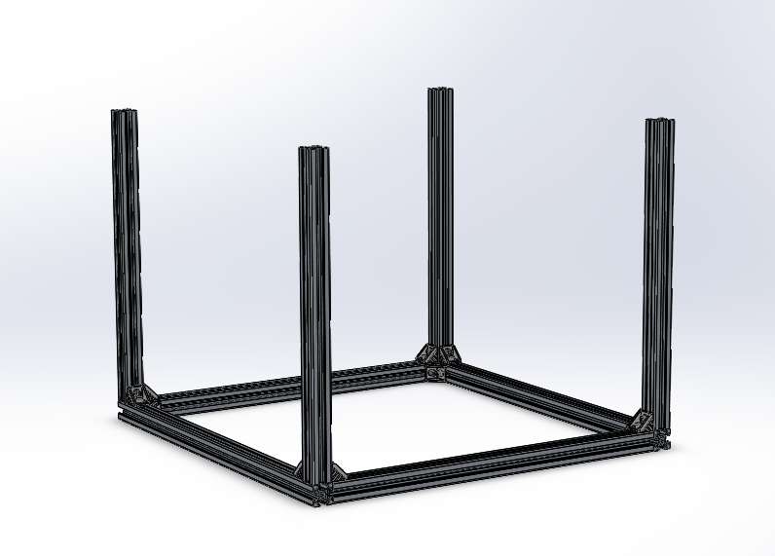

### Step 3

### Materials needed:

|  |  |
| --- | --- |
| **Quantity:** | **Description** |
| 8 | Fixation game |

### Description:

Take the assembly from the Step 2 and the remaining square from the Step 1, put the square above the assembly forming a cube, then use the fixation games to attach the square to the whole structure as shown in the image.

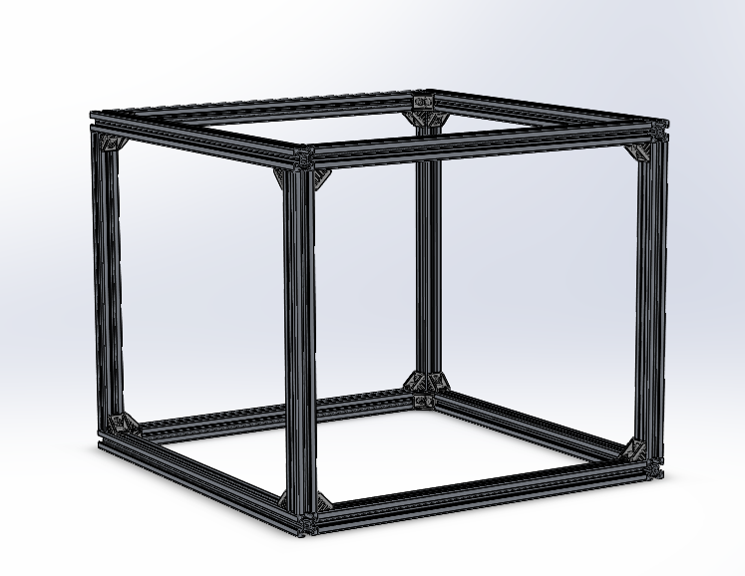

### Step 4

### Materials needed:

|  |  |
| --- | --- |
| **Quantity:** | **Description** |
| 1 | Piece 1 |
| 1 | Piece 2 |
| 4 | M4-45mm screw |
| 4 | M4 T-nut |

### Description:

Take the structure from the Step 3, (note: the last square that have been attached must be facing up), look for one of the shorts Rexroths and place Pieces 1 and 2 in each corner facing each other, then attach each piece to the Rexroths using the M4 screws and the T-nut.

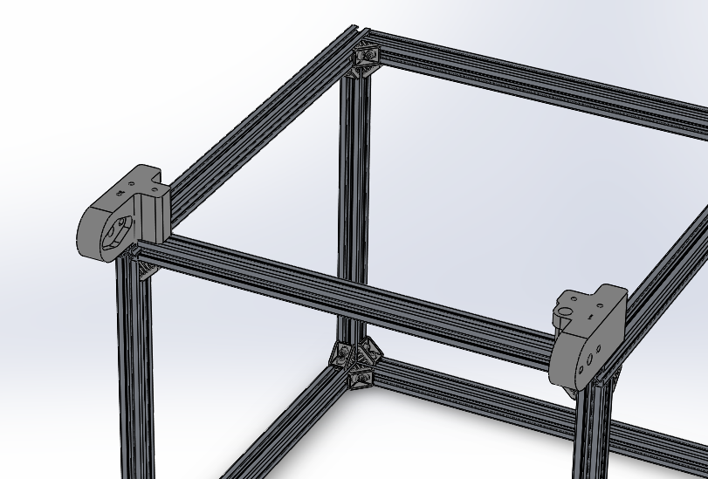

### Step 5

### Materials needed:

|  |  |
| --- | --- |
| **Quantity:** | **Description** |
| 1 | Piece 8A |
| 1 | Piece 8B |
| 1 | Piece 9 |
| 10 | Linear bearing |

### Description:

This step is for preparing the pieces 8A, 8B and 9. Firstly take a file and clean the holes of the pieces. Once the pieces has been cleaned take the linear bearings and put them inside the piece, the help of a nylon hammer may be needed.

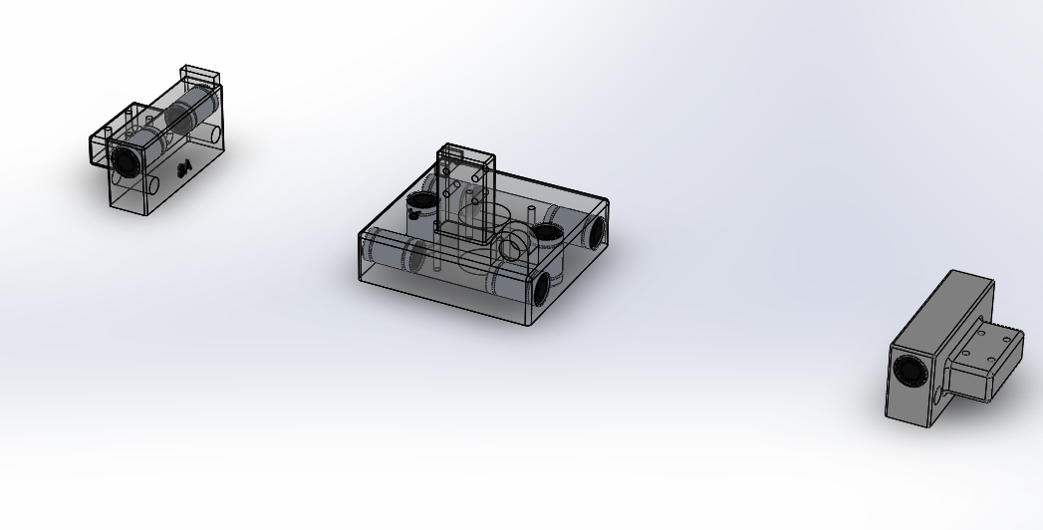

Here you can see in detail how the bearings need to be placed:

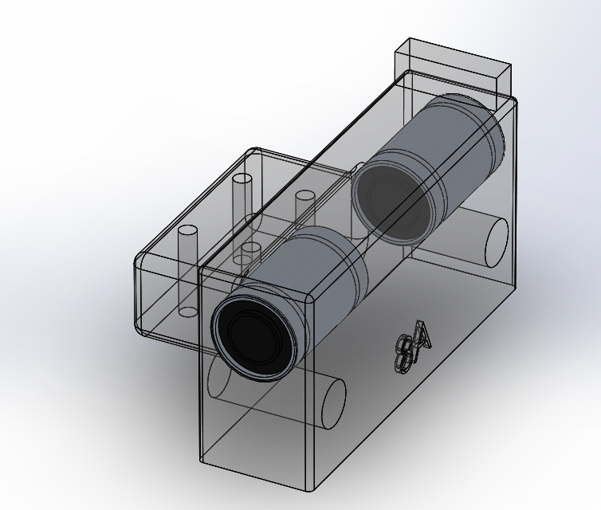

### Step 6

### Materials needed:

|  |  |
| --- | --- |
| **Quantity:** | **Description** |
| 2 | 8mm Rod-400mm |
| 1 | Piece 5 |
| 1 | Piece 7 |

### Description:

Take the pieces from the Step 5 and the two rods, firstly insert the rods into the free 8mm of the piece 8A, then slide the rods into the four lineal bearings placed into the piece 9, finally close the structure by inserting the piece 8B as shown in the second image.

Once that has been done, insert the outgoing part of the rod from the piece 8A into the holes of the piece 7.

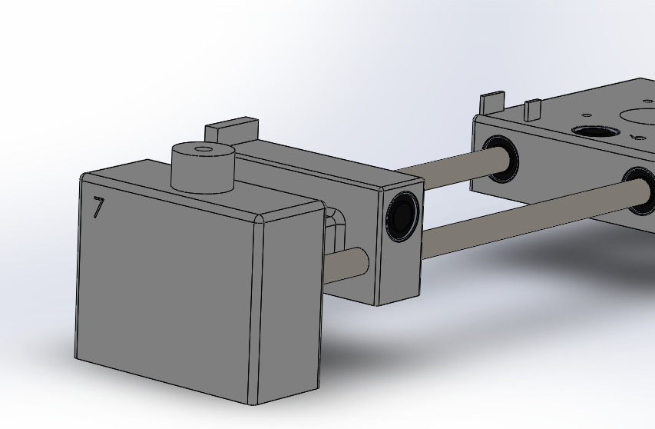

Finally, repeat the exact same process with the piece 5 in the other side.

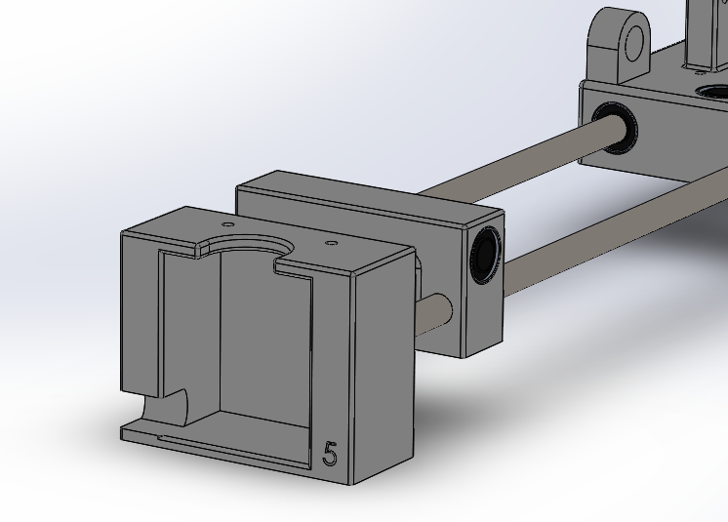

### Step 7

### Materials needed:

|  |  |
| --- | --- |
| **Quantity:** | **Description** |
| 1 | Nema 17 motor |
| 1 | 5mm transmission pulley |
| 1 | Synchronous pulley |
| 2 | M3x10mm screws |
| 1 | M5x50mm screw |

### Description:

Take the structure from the step 6, place the motor inside the piece 5 and then attach it by using two the two M3 screws, then place the 5mm transmission pulley into the motor shaft.

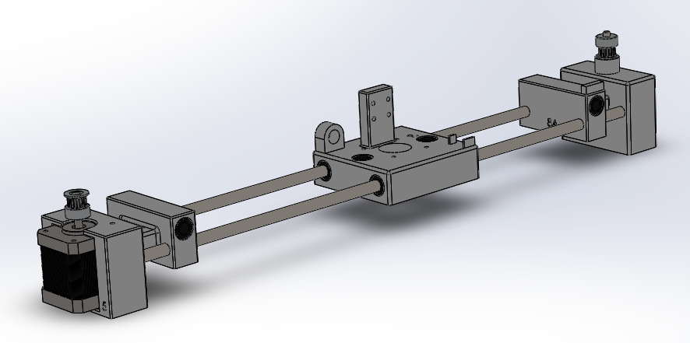Once that has been done take the synchronous pulley and the M5 screw, attach the synchronous pulley directly into the top hole of the piece 7 (note: do not attach it to strong, the pulley must be able to move freely).

### Step 8

### Materials needed:

|  |  |
| --- | --- |
| **Quantity:** | **Description** |
| 2 | 8mm Rod-370mm |

### Description:

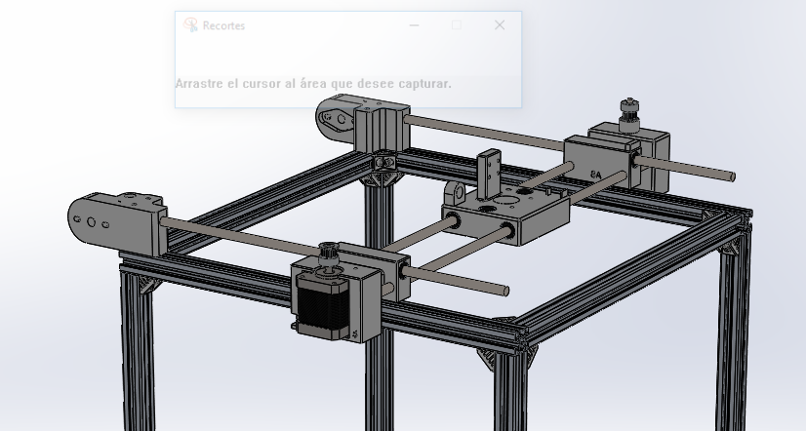In this step we are going to join the structure from the step 4 and the one from the step 7, for that take the two rods and place it into the holes of pieces 1 and 2, then put the structure from step 7 sliding the rods into the linear bearings from pieces 8A and 8B.

### Step 9

### Materials needed:

|  |  |
| --- | --- |
| **Quantity:** | **Description** |
| 1 | Piece3 |
| 1 | Piece4 |
| 4 | M4x45mm screw |
| 4 | M4 T-nut |

### Description:

To close the assembly got in the step 8 take the piece 3 and 4 and insert the outgoing rod from step 8 into the free hole of the pieces 3 and 4, then take the screws and the T-nuts and attach the pieces to the Rexroths.

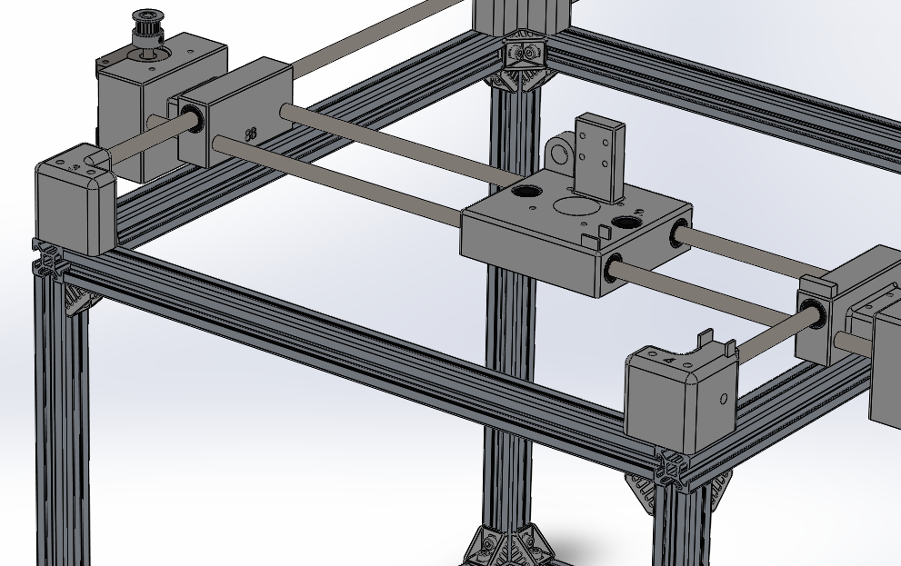

### Step 10

### Materials needed:

|  |  |
| --- | --- |
| **Quantity:** | **Description** |
| 2 | IGUS bearing |
| 4 | M4x25mmm screw |
| 4 | M4 nut |

### Description:

Take the IGUS bearings and put each one into the piece 1 and 2, then take the screws and the nuts and attach them firmly to the piece.

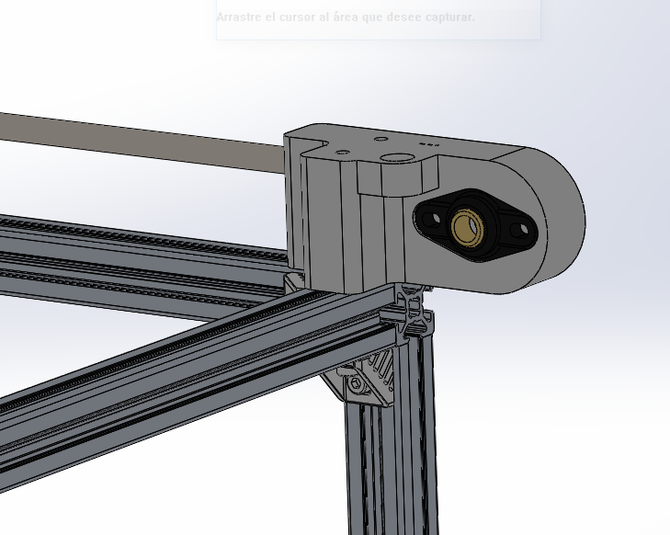

### Step 11

### Materials needed:

|  |  |
| --- | --- |
| **Quantity:** | **Description** |
| 1 | Piece 6 |
| 1 | 8mm Rod-420mm |
| 3 | 8mm transmission pulley |
| 1 | 5mm transmission pulley |
| 1 | Nema 17 |
| 1 | M4x15mm Screw |
| 1 | M4x10mm Screw |
| 2 | M4 T-nut |

### Description:

Take the 8mm rod and pass it through the IGUS bearing, then put in their place (as shown in the image) the 8mm transmission pulleys and attach them in place.

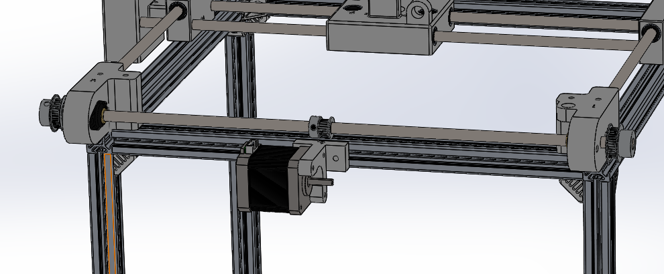

Take the piece 6 and attach it to the Rexroth by using the two M4 screws and the two T-nuts as shown in the image. Finally take the motor and attach it to the piece 6 by using the three M3 screws, then take the 5mm transmission pulley, place it into the motor shaft and attach it there.

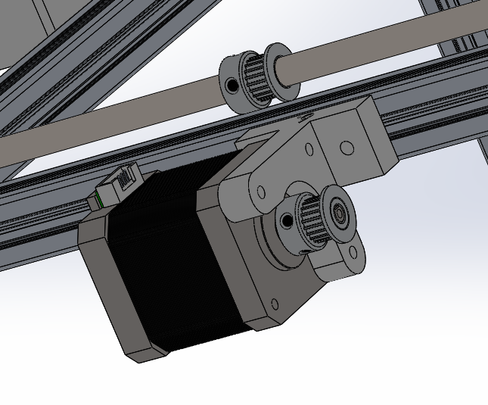

### Step 12

### Materials needed:

|  |  |
| --- | --- |
| **Quantity:** | **Description** |
| 2 | Synchronous pulley |
| 2 | M5x45mm Screws |
| 2 | M5 autoblocking nut |

### Description:

Take the synchronous pulleys and attach each one to the pieces 3 and 4 by using the screw and the autoblocking nut (note: do not attach it to strong, the pulley must be able to move freely).

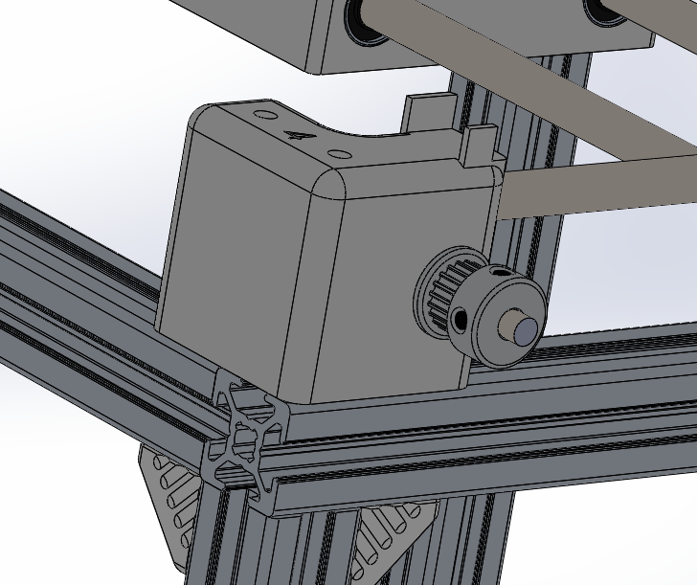

### Step 13

### Materials needed:

|  |  |
| --- | --- |
| **Quantity:** | **Description** |
| 1 | Nema 17 |
| 1 | Lead screw |
| 1 | Shaft coupler |

### Description:

Take the shaft coupler and place it into the motor shaft, then attach it there, once that has done place the lead screw in the other hole of the shaft coupler and attach it there.

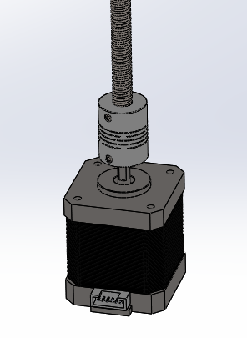

### Step 14

### Materials needed:

|  |  |
| --- | --- |
| **Quantity:** | **Description** |
| 1 | Lead screw nut |
| 1 | Piece 10 |
| 2 | 8mm Rod-310mm |
| 4 | M3x30mm Screws |
| 2 | M3x35mm Screws |
| 2 | M3 autoblocking nut |

### 

### Description:

Take the assembly from the step 14 and place it inside the piece 9, attach the motor to the piece by using the 4 M3x30mm screws, then screw the lead screw nut into the main lead screw, finally take the two 8mm rods and pass them through the linear bearings inside piece 9.

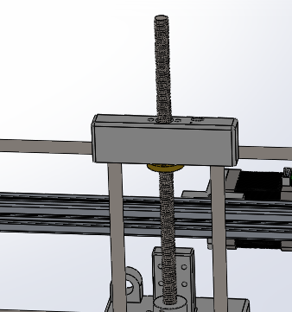

Finally join the rods and the lead screw nut by placing the piece 10, insert the 8mm rods into the free 8mm holes and then attach the nut by using the two M3x35mm Screws and the autoblocking nuts.

### Step 15

### Materials needed:

|  |  |
| --- | --- |
| **Quantity:** | **Description** |
| 1 | Piece 11 |
| 2 | BRAKETS |
| 4 | M3x25mm Screw |
| 4 | M3 nut |

### Description:

Take the piece 11 and place it under the assembly made in the step 13, insert the outgoing rods into the piece 11.

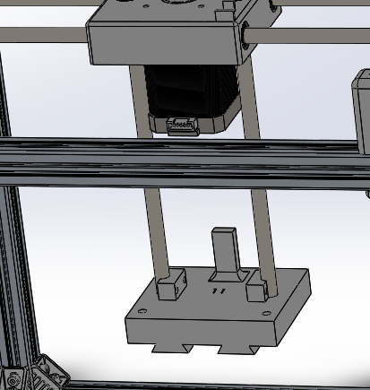

Finally put the brakets in place and tight the rods by compressing the brakets to the piece 11 using the M3 screws and the M3 nuts .

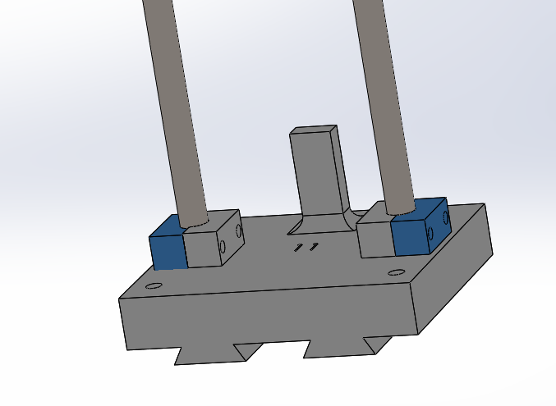

### Step 16

### Materials needed:

|  |  |
| --- | --- |
| **Quantity:** | **Description** |
| 1 | Wood Board |

### Description:

A board of wood 20mm thick needs to be cut following this pattern, to do that we did used the milling machine but it can be done by hand.

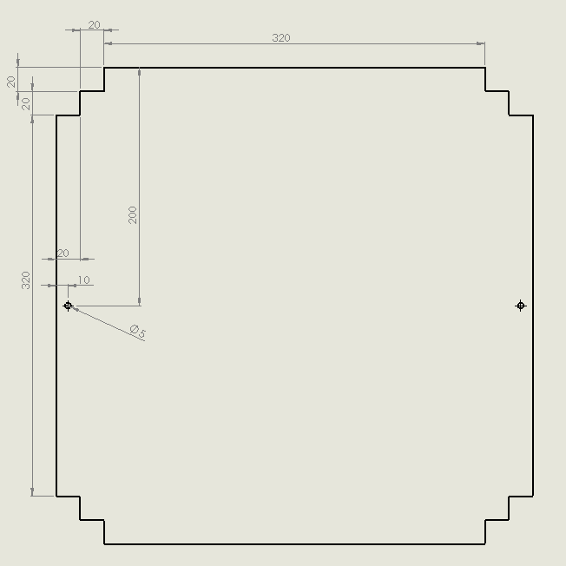

### Step 16

### Materials needed:

|  |  |
| --- | --- |
| **Quantity:** | **Description** |
| 1 | Wood Board |
| 1 | Electronics enclosure |

### Description:

As the final step, all the wiring must be done and we just need to place the wood board at the bottom of the machine and then place all the electronics into the electronics box (see more about electronics in *Electronics and Firmware* Step).

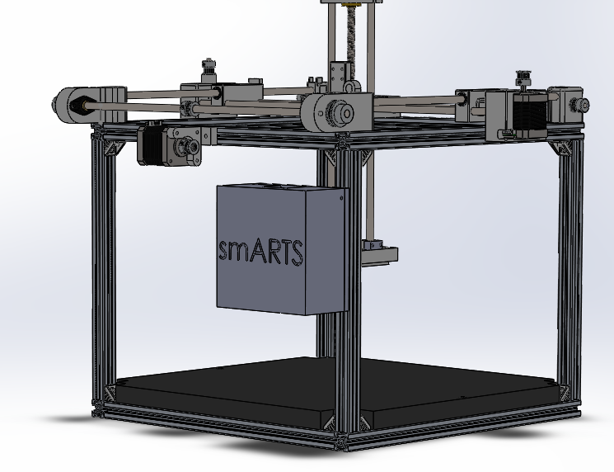

### Step 17

This is an extra step to show the configuration we have chosen for the lighting and the image acquisition, as this is a modular machine other designs can be implemented to fit the machine.

The lighting system we have design and tested is a directional one, which the X-axis and the angle of incidence can be moved and modified.

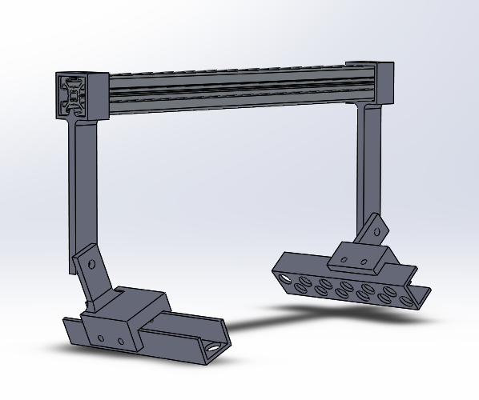

To get the image acquisition we have used the following system in which we have an Arduino UNO and two tilting arms where we can place the cameras.

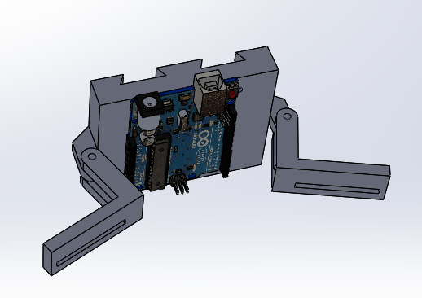

## 6. Electronics and Firmware

### Electronics

About the electronics, as well as the whole project, the main objective was to develop an easy to replicate and open source board. That is the reason we´d chosen an *Arduino* as our main controller.

*Arduino* is an open source project which involves different boards, so among all the variety we chose the *Arduino MEGA*, the one in which we could upload the *Marlin* firmware.

Therefore, we had the necessity to joit all the components into a circuit, that’s the reason we have designed our own Circuit Board around the *Arduino MEGA* controller.

### Required materials

Here you can see the materials needed to replicate the main board:

|  |
| --- |
| * Arduino MEGA (1 unit) |
| * DRV8825 stepper controller (3 units) |
| * ATX PC power supply (1 unit) |
| * Nema 17 stepper motor 400 steps per revolution (3 units)* |
| * End stop switch NO (3 units)* |
| * 1uF electrolytic capacitor (3 units) |
| * 1kΩ 1/4W resistor (4 units) |
| * Prototype perforated board 100mmx100mm (1 unit) |
| * Drivers stepper motors (3 units) |
| * IRF520N MOSFET (1 units) |
| * 330Ω 1/4W resistor (2 units per light system)* |
| * 3mm UV LED (10 units per light system)* |
| * Coper cable 0.75mm (10 meters) |
| * 2.54mm Male Pin (20 units) |
| * Arduino Mega (1 units)   *These components don’t go soldered directly to the main board |

### Circuit board construction

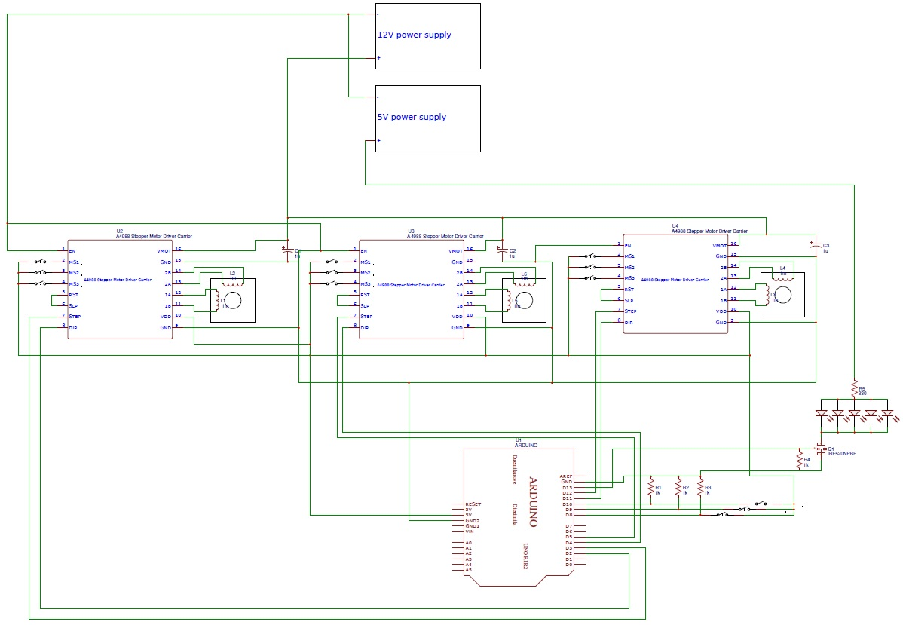Once we have all the components we must build the board following the circuit (Check the document *“smARTS Circuit”*):

*Notice that the highlighted components in the material list doesn’t go soldered directly into the board, instead, they need to go soldered with some cables to place them in the mechanical structure (See the image below).

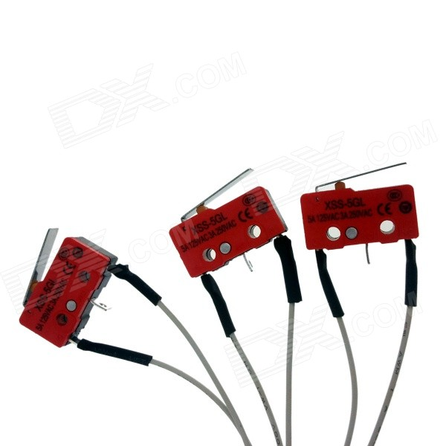

Finally, here we can see the resulting board we got:

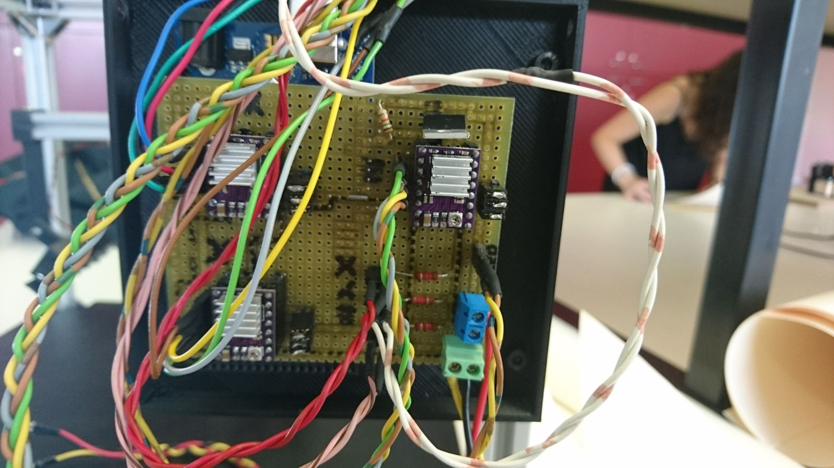

Seen the image, you can appreciate some extra features (which weren’t mandatory) we decided to add to make easier the job:

* Instead of soldering the motor driver directly to the board, we used some female connectors to change it easily in case they get burned.
* We also added some connectors for the power cables from the power supply.

### Firmware

In order to have a working machine the Arduino Mega needs to run a code. The main objective of this code is to understand the commands sent by the PC and move the correspondent axis to the desired position. Therefore, the firmware needed to run the Arduino has to be an universal G-Code interpreter, among all the variety we did found we decided to choose Marlin, and do the pertinent modifications in order to adapt it to our machine.

*The Modified version of the Marlin firmware can be found on smARTS GitHub site.

Here we are going to explain the changes we did to the original code.

Firstly, before doing nothing we got sure that the serial port the Arduino was using was the 0, and that the baud rate of the communication was able to be achieved by our PC program (250000bps is good enough).

Once we were sure about that we proceed to do the changes, the first one was to define the board as a: “BOARD_RAMPS_OLD”, this change has to be done in the Configuration.h tab.

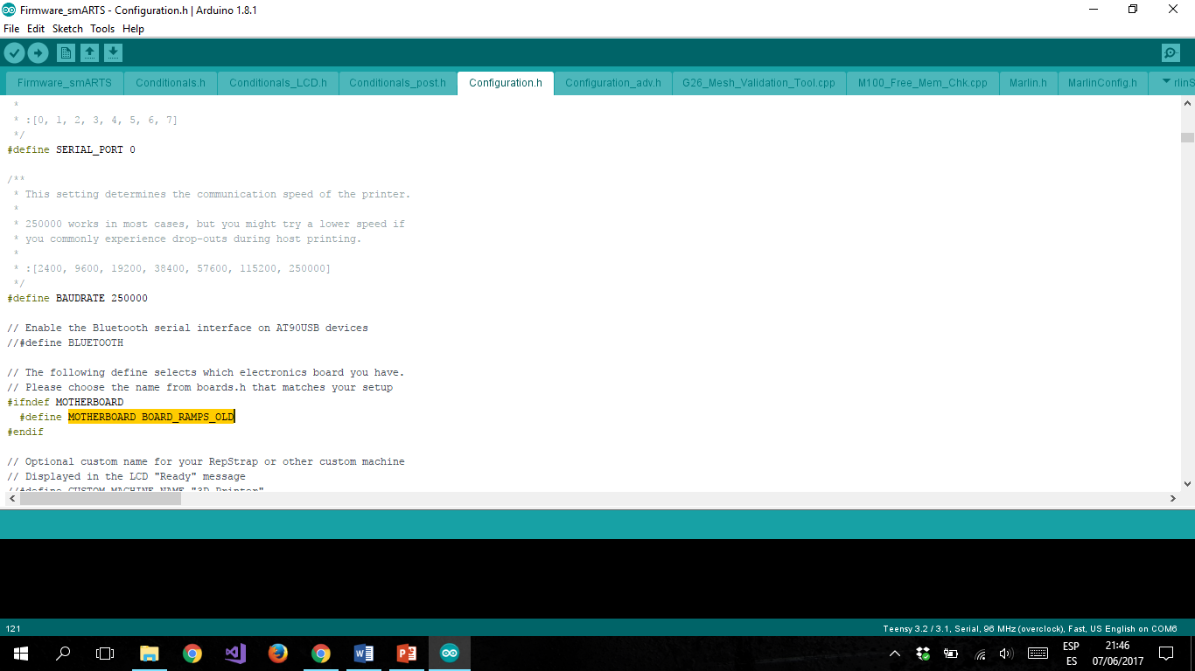

The second change we did was to comment the lines that enable the internal pull-ups of the controller in the pins we have the end stops, we did that because we already have an external pull-down in our circuit”, this change has to be done in the Configuration.h tab.

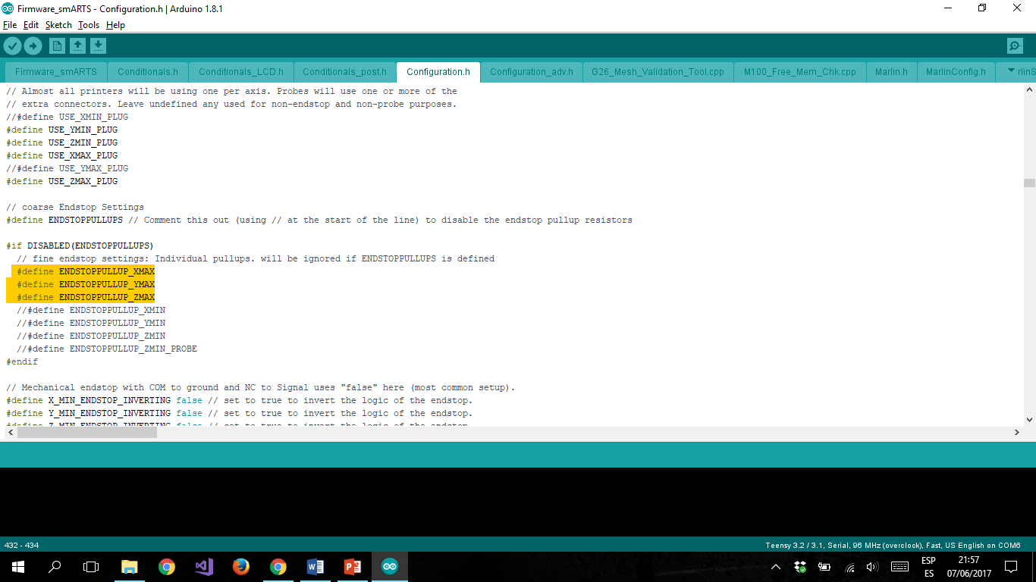

The third change we did was to set the inverting logic of all axis to false, this change has to be done in the Configuration.h tab.

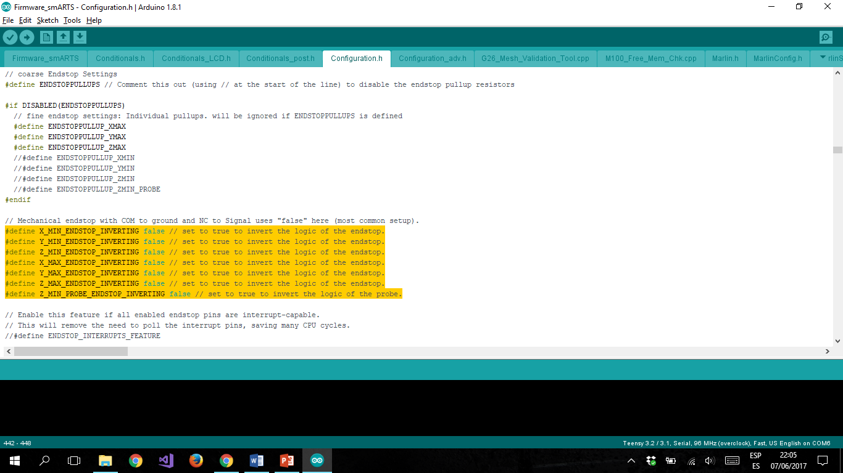

The fourth change we did was to define the steps per mm we had to give to the steppers, these values came from the combination of the numbers of teeth of the pulley, the steps per revolution of the motors and the microstepping from the drivers, this change has to be done in the Configuration.h tab.

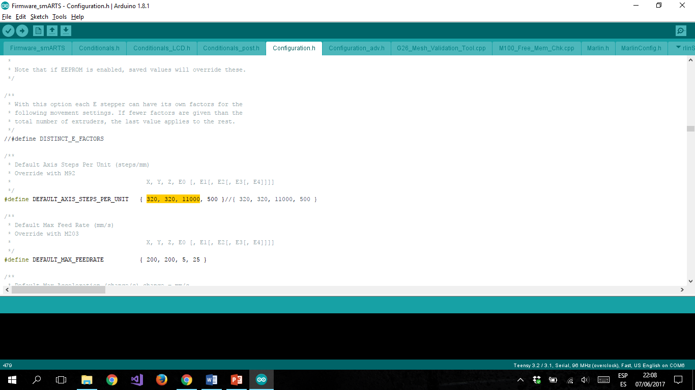

The fifth change we did was to set the maximum acceleration of each axis to 1000mm/s^2, this change has to be done in the Configuration.h tab.

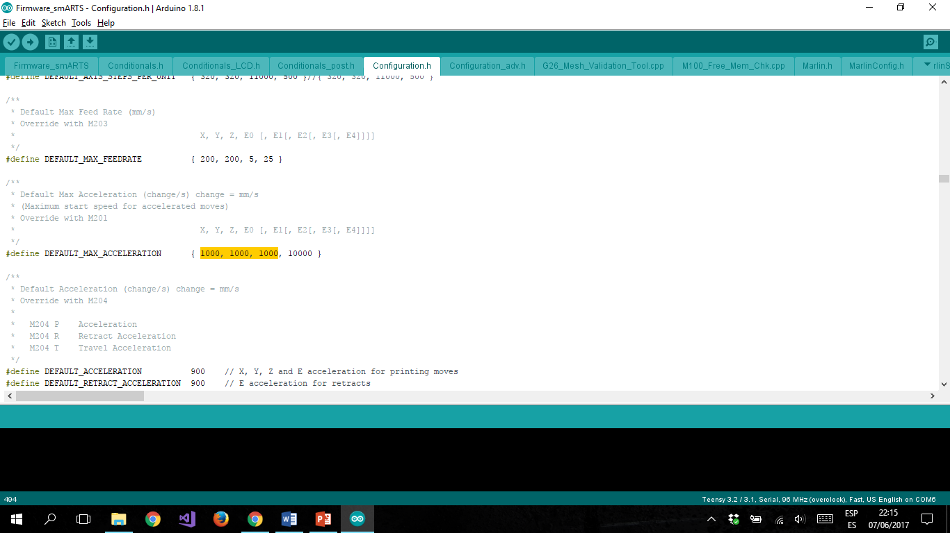

The last change we did was to set the pins were we connected the drivers and the end stops, this change has to be done in the pins_RAMPS_OLD.h tab.

|  |  |
| --- | --- |
|  |  |
|  |

## 7. Controlling software:

Our controlling software will be *Repetier-Host*. It is a free programme available in Windows, Linux and Mac, which is compatible with most firmwares around.

With this GUI we will be able to move the tool in a very precise way, using the manual control menu or programming a sequence using G-code.

Here are the steps to follow if you want to use this software:

1. Download *Repetier-Host* from: <https://www.repetier.com/download-software>
2. Open the setup file, install the programme and run it.
3. Once running, go to *Configuration* 🡪 *Printer* settings and configure it with the following parameters.
   1. Connection:

Connector: Serial Connection

Port: Auto (or put your COM if you know it).

Baudrate: 250000

* 1. Printer:

Travel Feed Rate: 2000

Z-Axis Feed Rate: 17000

Invert Direction Controls for: Tick Z-Axis

* 1. Printer Shape:

Printer Type: Classic Printer

Home X: Max

Home Y: Min

Home Z: Min

Print Area Width: 260 mm

Print Area Depth: 240 mm

Print Area Height: 110 mm

1. Configuration done! Now plug the power supply and connect the Arduino USB cable to the computer.
2. In the *Repetier-Host* main page press *Connect* to start using the machine.

### Manual Control:

To use the manual control you should go to the *Manual Control* tab located on the top right. Once there you will see an easy control interface as the following one:

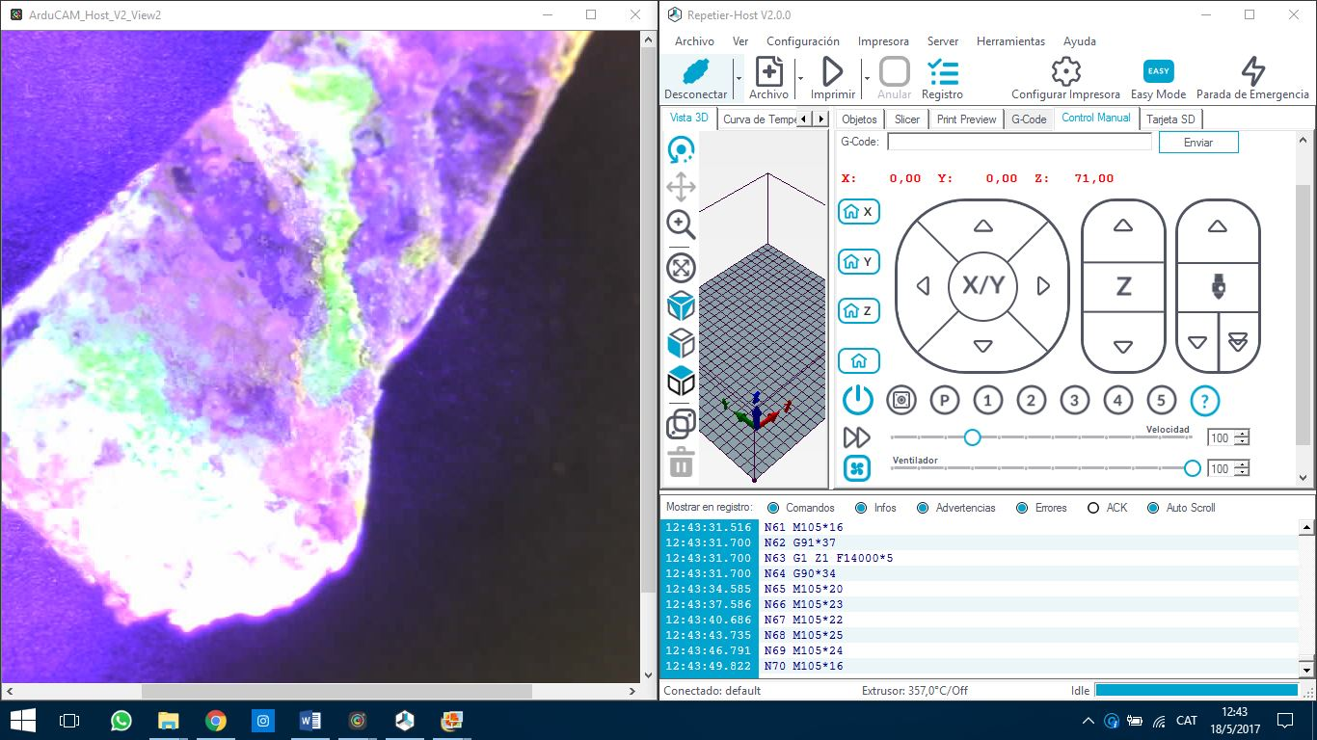

* **Homing buttons:** We use it to go to a single axis home position (first three) or to do a general homing (last one).

IMPORTANT! You must do a general homing every time you want to use the machine after it has been disconnected.

* **Movement buttons:** You can use it to move in the three axis in a distance between 0.1mm and 50mm.
* **Speed multiplier:** Moving this slider we can increase or reduce the nominal speed.
* **“Fan” slider:** In our case with this slider, we will activate/deactivate the illumination system and control the level of brightness.

### Sequence mode:

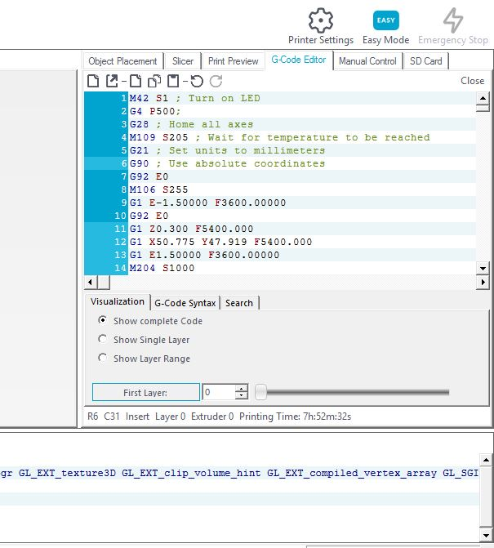To use this mode, you can import a G-code sequence or program your own.

* Importing a pre-created sequence: You should go to *File* 🡪 *Load* and select it. The G-code editor tab will be opened automatically.
* Create your own sequence: Go to the *Print Preview* tab on the top right. Once there press *Edit G-code* and start coding.

*If you need more information about G-code, we would like to recommend you to look for tutorials or visit the following webpage: <http://reprap.org/wiki/G-code>

## 8. smARTS useful links and repositories

Finally, we would like to invite you to the following web pages.

There you can download all the necessary archives and information if you want to replicate this project.

You also can be aware of the latest news related with the project or contact with us.

**GitHub UMecamat:**

<https://github.com/UMecamat>

**smARTS Web Page:**

<https://smartsuvic.wixsite.com/smartsuvic>

**Youtube Channel:**

<https://www.youtube.com/channel/UCSC1kqYAXKj60nb-Jbjp_hg>

**Mecamat Web Page:**

<http://mon.uvic.cat/mecamat/smarts>